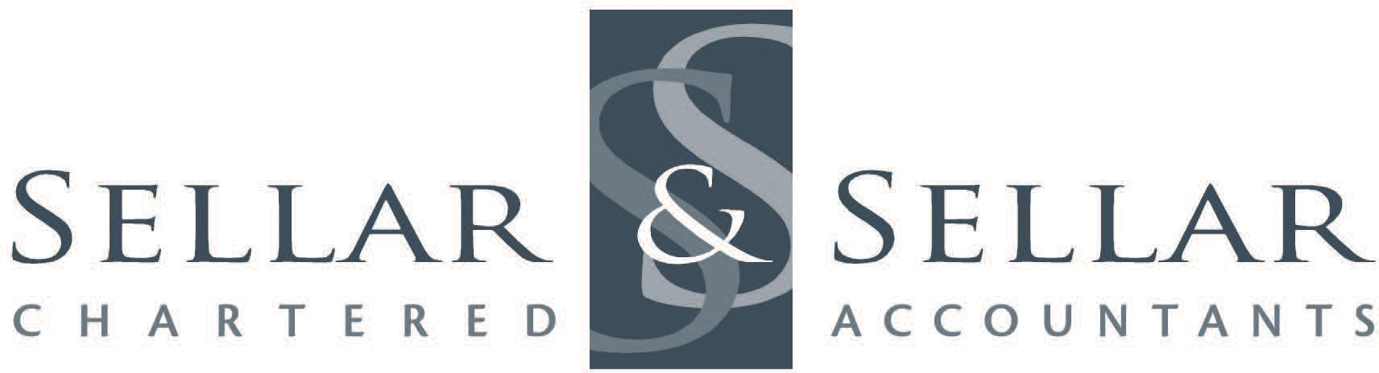
Financial Statements – 2023
Please ensure this is signed and returned with your records
Email:

Phone:

Client Name:

To: Sellar & Sellar

Terms of Engagement – Annual Confirmation

I/We hereby instruct you to prepare my/our Financial Statements and Taxation Returns for my/our financial year end 2023. I/We undertake to supply all information necessary to carry out such services and will be responsible for the accuracy and completeness of such information. I/We understand that you will rely upon the information provided by me/us. Your services are not intended to, and accordingly will not result in the expression by you of an opinion on the Financial Statements in so far as third parties are concerned, or in the fulfilling of any statutory audit requirements. I/We understand that during preparation of the Financial Statements and Taxation Returns you will not be specifically investigating non-compliance with laws and regulations – however, should anything come to light of this nature during this process, you will bring that to my/our attention.

I/We understand that the Financial Statements and Taxation Returns are prepared for my/our own use and to determine my/our taxation liabilities. If this should change in any material respect, I/we will inform you immediately. You will not accept any responsibility to any person, other than me/us, for the contents of the Financial Statements.

All other terms and conditions of this engagement are the same as those referred to in the original Engagement Letter I/we signed when I/we became a client.

I/We also accept that you have the right to charge interest on overdue accounts at the rate of 1.5% per month, and that all accounts are due for payment by the 20th of the month following invoice date. The charging of such interest will be at your discretion. I/We accept that any collection costs you incur will be fully recoverable from me/us.

You are hereby authorised to communicate with my/our bankers, solicitors, finance companies and all government agencies to obtain such information as you require in order to complete the above assignments. I/we authorise you to obtain information from Inland Revenue about all tax types except child support (NCP or CPR) in order to complete the above assignments. This includes obtaining information through all Inland Revenue media and communication channels.

You are to represent me/us as my/our tax agent. All income tax returns will be signed by me/us however you are authorised to sign any other taxation return on behalf of myself/ourselves or any of my/our associated entities.

Are you a Senior Member of NZ or Foreign Government, Judiciary, Military, or an Ambassador?
– or are you immediately related to any? Yes No (Tick One)

Signed on behalf

Date

Convenient time to call you is:
Alternative phone numbers are:
When do you want your accounts completed by?
Would you like us to supply a copy to your bank? | Yes No (Tick One)
If your accounts are to be supplied to your bank, please advise the name of your current bank manager:
Has the nature of your business changed in any way during the past 12 months? If yes, please provide brief details:

